Contents

Page 2 – Introduction
Page 5 – My nutrition principles
Page 6 – Gut Health
Page 8 – Recommended Eating Habits
Page 12 – Supplements
Page 18 – Adaptogens
Page 20 – The Glyceamic Index
Page 40 – Bonus Material & Recipes
Page 51 – Whey Protein Overview
Page 53 – Creatine Overview
Page 59 – 4,000 Calorie Diet Plan
Page 63 – The FODMAP Diet
Page 66 – The Ketogenic Diet
Page 74 – The Alkaline Diet
Page 77 – The Vegan Diet
Page 80 – The Paleo Diet
Page 84 – Intermittent Fasting
Page 90 – Carbohydrate Cycling
Page 94 – Expert Quotes on Diet
Page 98 – Final Thoughts

Please diet and exercise with caution and at your own risk

Introduction
Athletes are often concerned with dietary manipulations in the period around competition. However, the main role of nutrition may be to support consistent intensive training which will lead to improved performance. Meeting energy demand and maintaining body mass and body fat at optimal levels are key goals.
Often overlooked elements of Sports Nutrition however, include optimal dietary requirements for health, minimal systemic and muscular inflammation and enhanced immune function. A general feeling of wellbeing and energy are undervalued in Sports Nutrition but are fundamental for performance.
Nutritional Goals should include:
Maintaining energy supply to working muscles and other tissues
Promoting tissue adaptation, growth and repair
Promoting immune function
Reducing inflammation – a crucial marker in association with both recovery and general health.

Disclaimer – Consult your Doctor before adopting any dietary changes

Caveat for this book

Talking about nutrition has become like discussing politics and religion – everyone has an aggressive opinion. Nutrition is certainly no different.

Throughout my time as a student, reading Sport & Exercise Science at Loughborough and Nutrition Science at Chester; I was taught that fat was ‘bad’ and carbohydrates were ‘good’. As athletes, we were encouraged to drink carbohydrate drinks with meals for extra calories. To be fair, the high-carbohydrate protocol is supported by a large amount of research, showing that for sports such as rugby, football and boxing, it can improve performance, at least in the short term.

At this time there is emerging evidence for alternative protocols such as the ketogenic diet. These are addressed in the appendix at the end of the book. There’s no one-size-fits-all in the world of nutrition unfortunately, ideally diets would be customized according to an individual’s genetic makeup. This can now be done to a certain extent, with DNA testing from the likes of 23andme.

Inflammation
High carbohydrate diets, particularly high sugar diets (and other high glycaemic carbohydrates) can in some individuals, cause high levels of inflammation. Inflammation is directly linked to depression, physical diseases and poor recovery from physical activity. Again, in some, inflammation is heightened when processed foods, dairy and/or wheat is consumed.

In this book I have included carbohydrate drinks – e.g. maltodextrin based drinks as this is what research supports for optimal performance & recovery.

To avoid inflammation (and potential issues with gut flora) some may wish to replace some carbohydrate drinks and meals with those healthy fats, and sports drinks with coconut water and fruit such as a ripe banana.

Do what works for you
If you feel great, and you are full of energy and focus on a high carbohydrate diet, then great, carry on. In fact, there is a high-carbohydrate diet-plan included in this book, as research shows it can improve performance.
If however you are suffering any symptoms of high levels of inflammation, and/or high any gut problems like IBS, then consider switching to a diet with no sugar, no processed foods, and high levels of healthy fats, like those found in coconut milk, olive oil and fish.

Removing whole food groups from your diet, like diary and/or wheat is controversial, and many doctors would be against it. I however found that removing dairy from my diet completely, literally changed my life and increased my energy levels dramatically. I would recommend listening to the arguments for and against the likes of dairy, carbohydrates, ketogenic diets etc and make your own mind up. The Ted X talks on youtube are a good place to start.

My General Principles
- Focus on health & wellbeing as a base for recovery, mental focus & performance
- Eat a diet high in healthy fats and moderate in protein & carbohydrates day to day
- Eat lots of organic vegetables and fruits
- Avoid refined carbohydrates. They are useful (arguably) post match or workout when recovery is paramount. However refined carbohydrates will tend to impact gut health and cause inflammation

- Avoid vegetable oils like sunflower oil. They are high in omega 6 and have been heated so much during extraction that they become carcinogenic. Oils like olive oil are pressed and not heated during the extraction process, meaning that they are relatively healthy.
Gut Health
“All disease begins in the gut.” – Hippocrates

Inflammation is linked to almost all modern diseases. Inflammation often starts in the gut, and can lead to low energy levels, injury and burn-out. Importantly too – over 50% of the body’s immune system is in your gut, so you need to take care of it.

Here are some tips for improving gut health

- Improve the profile of your gut flora by consuming fermented foods and/or a probiotic supplement
- Again, improve your gut flora profile by reducing sugary, high GI carbs (unless required to meet high energy demands and for recovery)
- Drink glutamine on an empty stomach, first thing in the morning if ‘leaky gut’ syndrome is suspected
- Drink organic, apple cider vinegar – a tablespoon (or more, assess your tolerance) in water, drunk about 15 minutes before a meal improves digestion dramatically in most people.

- Gingko Biloba and NAC powder have personally helped with the IBS that I had. Gingko has a multitude of health benefits, but can thin the blood (usually not a bad thing), and increase the likelihood of a bleed on the brain

After giving up dairy and sugar I saw the biggest improvements in IBS. See appendix 1 for the FODMAP diet for IBS. The diet is a (long list) of foods to cut out for people who have trouble with IBS and bloating. Onions and garlic seem to be a problem for most people with IBS and/or bloating issues.
VSL 3 is also touted as a great supplement for those with gut issues, although I have not tried it myself yet.

General Eating Habits
If you take one message away from this book, please remember that healthy nutrition starts with healthy nutrition, organic whole foods, preferably cooked from scratch. If you are eating protein bars full of additives and collagen, you are just being duped by Sports Nutrition marketing.
Omega 3 to Omega 6 ratio
Western diets are full of Omega 6 fats, and highly processed, heated fats, that cause inflammation. Omega 6 causes inflammation, which is the enemy for recovery and general health.
The easiest way to adjust this balance is to supplement with fish oil and cook with coconut oil, instead of vegetable oils. EPA is the anti-inflammatory element of omega 3. Look for fish oil (and krill oil) high in EPA.
Addressing the omega 3 to omega 6 ratio can have a drastic impact on health and in turn on performance due to a reduction in inflammation. If inflammation is a general issue, then addressing omega 3 and 6 intake is the best place to start.
Pre & Probiotic Foods
Back in the day, we had dairy from one cow, it was raw, untreated etc. and full of goodness. Nowadays the milk (and most other products) come from about 1,000 cows, mass milked, full of drugs to make them produce more milk and anti-bioitcs to stop them getting infections, the milk has to be heated to 97 degrees so it doesn’t kill us…what you end up with, is a product that is on a different level (a lower one) to what our great, great grandparents and their mates drank.
If the balance of bacteria in our gut isn’t right, we’ll feel slugish and generally less well.

Although for most people, an imbalance in gut flora may cause mild fatigue, it can’t be over-emphasized how important this bacteria is. Imbalances have been linked to everything from autism to chronic fatigue and auto-immune issues.

Look to get some of these in your diet:
Raw honey, miso soup, kefir, dark chocolate, sauerkraut, kombucha tea (might be a bit on the yeasty side for some people), pickles and olives. Alternatively take a high quality probiotic supplement, 1 on an empty stomach and 1 later in the day with food.
High Quality Carbohydrates
Include sweet potatoes, buckwheat, quinoa and oats. Avoid sugar and High Glyceamic carbs, as sugar is highly inflammatory. The exception to this rule is when looking to increase carbohydrate intake over a short term period, or within 2 hours of an intensive exercise or training session.
Coconut milk and/or oil for extra calories
If you are struggling to consume enough calories try adding coconut milk to a smoothie with hemp seeds and fruit. Most commercial coconut milk, is 97% water and about 3% coconut milk. For extra calories get pure coconut milk, or as near as possible to pure coconut milk – try the tins or the dried coconut milk, rather than the cartons of coconut milk, which tend to be watered down.

Nuts have also been used in the past for extra calories, however recent research suggests that the human body is only able to assimilate around 70% of the calories found in nuts (source).
Avocados are also great blended in smoothies, olive oil and some people even throw in raw eggs. Having not researched the likelihood of salmonella I wouldn’t recommend the eggs myself

Experiment with Dairy and Wheat Free
Controversial but if your energy is low, this is worth a try. It’s not for everyone, but try it for a week and see how your body and digestive system feels. Dairy is also known to cause inflammation in many people. This is an especially good idea if you suffer from any bowel complaints such as IBS. See the appendix for the FODMAP diet for (potential) IBS treatment.

I personally used to have horrendous problems with asthma and sinusitis which have greatly improved since switching to dairy-free.

Experiment with Alkaline Foods
Some nutritionists claim that alkaline diets are superior for health and also endurance. Try adding wheatgrass and spirulina to your diet, and minimise the consumption of processed foods.

The whole alkaline diet concept remains controversial. Some claim it can prevent cancer, whilst others claim it does nothing for health. There is some research to suggest that baking soda (which is highly alkaline) can inhibit tumour growth. The alkaline diet is outlined in the appendix of this book at the end.
Consume natural anti-inflammatories
Eat more:
Ginger, Tumeric, Garlic, Onions, Red cabbage
High magnesium foods such as spinach, squash and pumpkin seeds and fish such as Mackerel
Try Pineapple for its bromelain content (you can also buy bromelain as a supplement)
Magnesium is also great for muscle relaxation if you are tense from training.
Eat/Consume less:
Alcohol, deep fried foods, artificial sweeteners and additives, sugar, vegetable cooking oils, dairy & processed meats as these can cause high levels of inflammation.
Nightshade fruits such as tomatoes are also linked to high levels of inflammation. Consider cutting down on these if suffering with knee, back or any joint inflammation.
Consume fresh, whole foods, in their original state if possible
Take table salt for example – consume sea salt or Himalayan salt, not table salt that has been bleached.
Another example – eat organic, grass fed beef, not processed meat. Eat organic food, that’s as fresh and ‘unprocessed’ as possible.
Broccoli Sprouts
If you are a fan of Dr Rhonda Patrick, you may well have heard about the health benefits of broccoli sprouts. Unfortunately, you have to grow them yourself.
Broccoli sprouts contain very high levels of a compound called Sulforaphane – an extremely potent antioxidant and anti-inflammatory.

Supplements

An ideal diet would contain largely raw foods, and no supplements. Having said that, in practical terms, I still think there is a place for supplements.

Fish Oil – Great for performance & Wellbeing
Look for fish oil with a high EPA content. This is the element of omega 3 that has anti-inflammatory properties. Supplement with 1 to 12g per day depending on the EPA content and your own muscle and joint soreness.

Gingko Biloba - Great for performance & Wellbeing
A great anti-inflammatory supplement that also enhances mental performance. If you are looking to increase energy levels, mental focus and/or enhance recovery rate, consider supplementing with Ginkgo Biloba.
Greens Powders - Great for performance & Wellbeing
If you struggle eating enough organic fruit & vegetables, consider supplementing with ‘greens’ powders such as wheatgrass and spirulina.

Leucine
There is some research to suggest that Leucine greatly enhances protein synthesis via the mTor pathway – however there is also research to state the it increases the growth & division of prostrate cancer cells. So use with caution.

Magnesium - Great for performance & Wellbeing
Magnesium is required for muscle relaxation. If you suffer from sore muscles and a stiff back and neck, try supplementing with magnesium. Check your tolerance though, as it can cause loose bowels if you take too much. Chelated versions of magnesium are absorbed most efficiently, but can make you feel tired in the short term so take before bed.

Medium Chain Triglycerides (MCTs)
Found naturally in coconuts, MCTs can provide extra calories when required and possess many health benefits. They are said to have benefits for the gut and to possess anti inflammatory benefits.

Creatine – Consume Daily – Ideally Post-Training
Creatine monohydrate, consumed with simple carbohydrates such as dextrose have been shown in dozens of studies to enhance intermittent high intensity exercise performance. Research suggests ‘loading’ (taking 20g of creatine a day for 5 days) is not necessary. Instead consume 3g a day with 20-30g of dextrose or another simple carbohydrate such as maltodextrin. Post-training is the ideal time to consume a drink containing creatine and carbohydrate.
Research also suggests that consuming 1000mg of alpha lipoic acid immediately before consuming a creatine/carbohydrate drink, enhancing skeletal muscle uptake.

Meriva Curcumin – arguably the strongest ‘natural’ anti-inflammatory
Curcumin is the main ‘active-ingredient’ in turmeric. Meriva curcumin, is curcumin combined with a phospholipid to make it many times more bio-available (ie. Your body absorbs and utilities a lot more of it per gram than standard curcumin).
There’s lots of research to show it’s great for reducing inflammation.

Inflammation is also related to stress and mental illness, so anything that reduces it, is almost always good.

Tart cherry juice is also a great natural anti-inflammatory, as is rosehip.

Supplements for Energy & Focus

Acetyl-L-Carnitine – Consume pre-training / fight
Great caffeine free supplement for enhancing mental power and physical energy. Try a small amount to begin with, as it can cause stomach upset if you are not used to it. I use 200mg for an endurance boost, but others advocate 2-3g. Please note, although prior research suggested that L-carnitine was good for the heart, recent research suggests it may change gut bacteria if used frequently, which in turn can accelerate atherosclerosis.

Taurine
If you ‘suffer’ from pumped up muscles, stiff shoulders when striking and/or pumped forearms when grappling, that weaken your grip, then taurine may very well help. Consume 3g about 30 mins before training. Do not take at the same time as beta alanine, as they will compete for absorption.

Medicinal Mushrooms - Great for performance & Wellbeing
No, not magic ones, no for sports nutrition anyway. However mushrooms including chaga and Lions Mane, may help recovery and also improve alertness.
Lions Mane mushrooms for example can be purchased in powder form. They have been shown to increase nerve growth factor and increase alertness. As a result I believe they could increase performance and cognitive abilities.

Lion’s Mane Mushroom, an edible fungus that is full of antioxidants and is said to regulate blood sugar levels, improve cognitive abilities, and improve long-term brain health. You could also consider Ginseng, a root that enhances mental performance and is known for its energizing effects; this one could help you to get through a tough training regime! Ashwagandha, Indian Ginseng, has a similar energizing effect.

Vitamin D
Low levels of vitamin D are associated with stress and illness. Although correlation does not necessarily equal causation (i.e. low levels of Vitamin D in stressed people, doesn’t mean it’s the vitamin D that’s the problem), it is associated with a range of mental health problems including depression when its levels are low.

Exposure to the sun is the most efficient way to increase vitamin D levels, whilst those of us who work in offices should consider supplementation.

1,000iu is generally considered a safe dosage, although some nutritionists recommend up to 4,000iu

Vitamin D is best taken with vitamin K2 which is found in fermented foods such as sauerkraut.

Adaptogens

Adaptogens are a group of herbs and foods that are able to offset some of the effects of physical and mental stress on the body.
If you are struggling to recover in between training sessions, then they are worth considering as part of your nutritional regime.
Korean Ginseng
The most famous adaptogen there is. Stacks of research to show that this herb increases immune functioning and reduces fatigue. Study
Rhodiola Rosea
Rhodiola rosea is a flowering plant, which resides in all the ridiculously cold regions of the world. Including Iceland, North America, the Artic and the UK. It has been showed to reduce fatigue and enhance mental clarity. Study

Ashwagandha
Also known as ‘Indian Ginseng’, this herb is a powerful antioxidant. Studies suggest that this herb not only reduced stress and cortisol levels, it also ‘fights’ cancer. It is also a strong anti-inflammatory, suggesting that it will help enhance recovery. Study

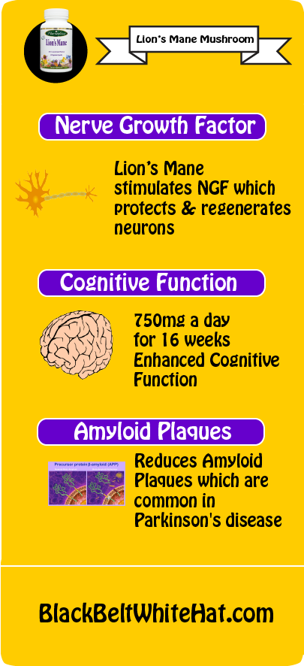

Natural Testosterone Boosters
These supplements have limited impact (don’t expect miracles or steroid like muscle-gain) but as a man in my mid-30s, I have personally found them useful for recovery and general vitality, as well as energy.
Fenugreek
It won’t make a huge difference to testosterone levels but can make you feel more vitality and perhaps help with recovery. Buy the powder from an Asian food store, not an overpriced supplement version. More info here.

Mucuna pruriens AKA Velvet Bean
Limited evidence for its effectiveness but I personally find it helpful. Use sparingly, as these herb also affects dopamine levels. Taken at night time, it also results in crazy dreams! More info here.

Tongkat Ali
There is a notorious amount of fake tongkat ali on the internet, but if you can get the genuine stuff then it’s been proven to reduce estrogen and libido. Limited research on its ability to directly increase testosterone.

Zinc
Ideally add zinc to your diet by consuming zinc-rich foods such as spinach.

For a full list of testosterone boosters, see the Examine.com webpage

The Glycemic Index

The Glycemic Index (GI) is basically an update to the concept of simple and complex carbohydrates. It is a measure of how quickly carbohydrates raise blood sugar level following consumption. It is relative to pure glucose. For example, if a piece of white bread has a GI of 70 – it would indicate that white bread raises blood sugar at a rate 70% as much as pure glucose; over a 2 hour period.
Generally an athlete should look to consume foods with a GI of 60 or below. It is important to note however, that as low GI foods take longer to digest, than can cause GI distress in some individuals. It is also less practical to get all of an athletes carbohydrate requirements purely from low GI carbohydrates. A mixture of GI types/scores is therefore often recommended. GI has little impact on carbohydrate loading.
The Glycemic Load (GL) is a number that estimates how much a food will raise a person’s blood sugar level by. High GL foods, like high GI foods cause blood sugar to rise rapidly. Very high GL foods should ideally only be consumed within 2 hours after a training session or fight.

GI aside, appropriate timing of carbohydrate intake is also vital. Research has shown that carbohydrate supplementation during soccer matches has been found to result in muscle glycogen sparing (39%), greater second-half running distances, and more goals being scored with less conceded, when compared to consumption of water. Carbohydrate supplementation has been recommended prior to, during, and after matches.

In a separate study, movement analysis of a 4-a-side indoor soccer game lasting 90 min was undertaken following 48 h of high (approx. 8 g/kg/day) or moderate (approx. 3 g/kg/day) carbohydrate intake. The high-carbohydrate diet increased muscle glycogen by 38% and allowed soccer players to complete approximately 33% more high-intensity work during the game.
If you weigh 80kg, 8g per kg per day is 640g of carbohydrate and 2560 calories just from carbohydrate. This is a lot of carbohydrate to eat daily! This is especially true if you rely on whole foods, with low GI properties to be the primary source of carbohydrate in your diet. Smoothies and drinks are a great way to get more carbohydrate in an athlete’s diet, whilst minimizing GI discomfort and bloating.
To ensure that the ideal amount of calories are being consumed, a coach should monitor the team’s body fat percentage, and waist circumference. An athlete can work out their approximate calorie requirements by doing the following:
– First start by working out Basal Metabolic Rate (BMR) using the below equation (or just use an online ‘BMR calculator’):

For men: BMR = 10 x weight (kg) + 6.25 x height (cm) – 5 x age (years) + 5
For women: BMR = 10 x weight (kg) + 6.25 x height (cm) – 5 x age (years) – 161
– Then use the Harris Benedict Formula, to work out your calorie requirements, based on your physical activity levels:
– If you exercise 1-3 days a week, x your BMR by 1.375
– 3-5 days a week BMR x 1.55
– 6-7 days a week BMR x 1.725
– if you have a physical job and train most days, BMR x 1.9

Author’s note – Although research suggests a high carbohydrate diet is the mainstay of any athlete’s diet and results in an enhanced athletic performance in most sports lasting longer than 60 seconds; consuming a vast amount of carbohydrate every day, may cause inflammation and not be the best for long term health. To offset any negative health effects of ‘sugary’ carbohydrates; consume high GI carbohydrates within 2 hours of training and the day before a fight.
Some nutritionists and recent research suggests that eating fats from nuts, fish and hemp for example, may be a more healthy way to reach calorific needs day to day. Then 2 days before a fight or competition increase carbohydrate intake and decrease fat intake to load the muscles and liver with glycogen (carbohydrate). See the next section on Ketogenic diets.

A Quick Note on Ketogenic Diets
This is where it gets somewhat confusing. A growing number of nutritionists and athletes are now recommending ketogenic diets over high carbohydrate diets – not only for weight loss, but for athletes. This goes against ‘traditional’ thoughts in sports nutrition, as to enter ketosis, an average person would have to eat less than 40g of carbohydrate per day.
There is some research to suggest that high carbohydrate diets (especially high GI) and grains can cause systemic inflammation which is a primary marker for many diseases and also has major implications for recovery and performance.

This is not something that I can claim to be an expert on. However, having given up sugar and replaced it with coconut milk as my main source of ‘additional’ calories, I have noticed a marked decrease in inflammation and bloating.

If you are interested in a ketogenic diet, then have a read of Rob Wolf’s and Mark Sisson’s blogs. There is research suggesting that when an athlete’s body does become ‘fat-adapted’, it can enhance endurance performance. See a study here.

Benefits of the keto-diet i(some proven, some not) include:
Improved blood lipid profiles
Lowered body fat
Increased energy – ketones are touted as a superior fuel for focus and physical energy
Stable blood sugar levels
Reduced Inflammation and neuroprotection (protects brain cells and/or brain function in some manner)

Research in regards to ketogenic diets is very promising, although I’m not 100% convinced on the suitability of the diet for power athletes. At this point in time, I’m personally sticking with a diet with moderate amounts of carbohdrates, and healthy fats. No sugar, no grains. I’m also slowly introducing MCTs into my diet.

Remember that it can take a month to become ‘fat-adapted’ and during that adaptation phase, you can feel pretty lousy.

Wellbeing Hacks

Bounding

Sunlight

Grounding

Psoas Stretches

Neck Stretches

Whole Body Stretches

HIIT & Tabata Intervals

10 Breath Holiday

Saunas

Suggested Next Steps

Level 1

Looking to implement small, but highly significant changes that won’t mean completely changing your lifestyle? Try these:

10 Breath Holiday

Magnesium

Meriva Curcumin

Psoas Stretch – Coil

Level 2

5 Minute Daily Meditation – in the car?

Bounding

Bonus Material
Additional Information



General Recovery and Injury Prevention Tips
It is highly recommended that any change in routine is piloted in training, before a competitive fight , as individual preferences and tolerances impact the effectiveness of each strategy Extensive warm up
In cold environments, muscle temperature should be increased as much as practically possible. This reduces the chance of injury and increases maximum power-output.
The increased power output of course, consumes more calories (as more physical work is done). The extent of the warm up may need to be tailored to offset any risk of dehydration and fatigue; in warm and human environments for example.
Sip on a carbohydrate/electrolyte drink during the warm up to offset any dehydration.
Dynamic stretching is recommended as part of a warm up as opposed to static stretching - the warm up should built up in intensity and replicate as closely as possible, the actual movements and actions of the game to come.
Cool down Light dynamic stretching, 20 min cycle/low impact low intensity exercise. Foam roller. Will enhance recovery. Consume foods with anti-inflammatory properties within 5 hours of a fight; including turmeric, ginger, pineapple and/or oily fish.

Easy Recipes

Ideally we would all be living in caves, drinking milk from our goat and foraging for berries, then cooking meals from scratch. In practical terms however, when faced with the goal of eating 3,500 calories a day, one typically, will need to fall back on a few ‘lazy’ tactics to get enough consumed per day.
Eat fresh, organic foods whenever possible, and cook from scratch whenever possible. If it’s not possible, try blending stuff. I personally don’t eat or recommend dairy; so where milk is used I would substitute with coconut milk or coconut oil instead of butter.

Healthy Fish & Chips
Defrost some frozen fish of your choice (preferably wild, dolphin friendly fish (farmed fish is full of carcinogens and synthetic chemicals)
Preheat oven to 200ºC
Slice sweet potato into wedges, cover in black pepper, Himalayan salt and olive oil
Cook for 35 to 40 minutes
Fry fish in frying pan with olive oil or coconut oil
or poach salmon in a pan full of hot water and butter for 15-20 minutes
Serve fish with sweet potato chips and a large handful of spinach
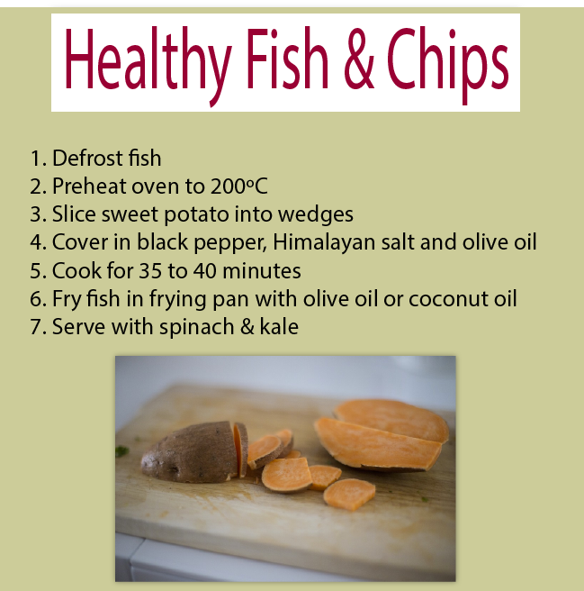

Super-Lazy Smoothie
Ingredients
40g hemp seeds or whey protein (unflavoured ideally)
1 banana
1 handful of raspberries
30g porridge oats
5ml hemp oil/olive oil
1 pinch of Himalayan salt
10g Flax-seed powder
5 Spinach leaves
50-100ml of coconut milk
200-300ml water
Instructions
Blend all the ingredients for 30-60 seconds
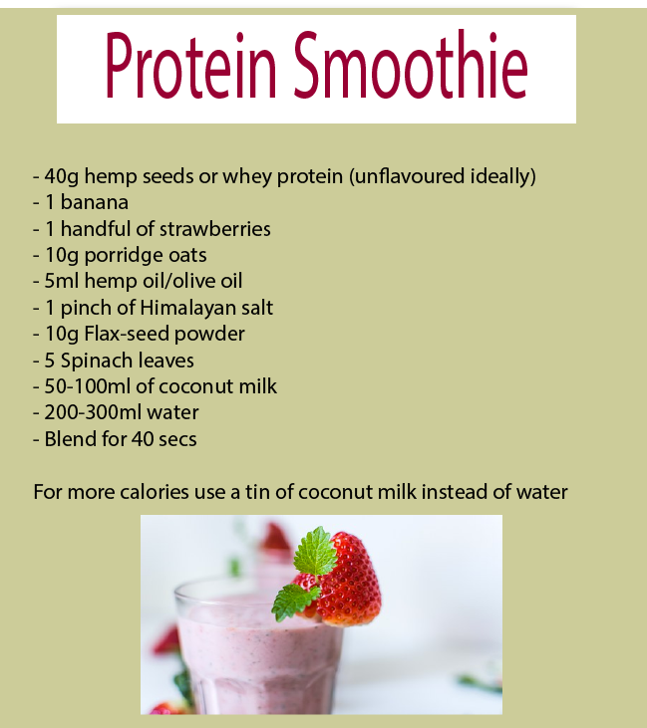

Super Lazy High Protein Porridge
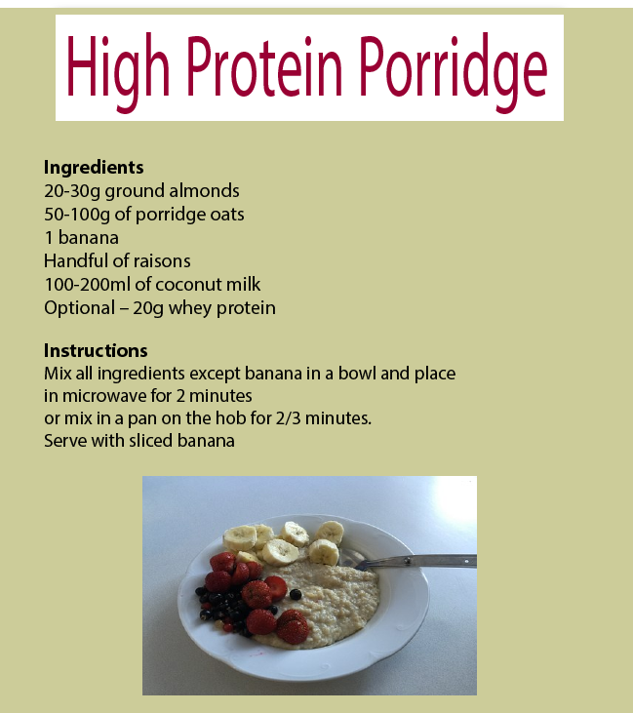
20-30g ground almonds
50-100g of porridge oats
1 banana
Handful of raisons
100-200ml of coconut milk
Optional – 20g whey protein
Instructions
Mix all ingredients except banana in a bowl and place in microwave for 2 minutes / mix in a pan on the hob for 2/3 minutes. Serve with sliced banana

Super-Lazy Pasta
Ingredients
Ideally you would make your own pasta sauce using fresh tomatoes, onions, garlic, black pepper and vinegar. Freeze the sauce and reuse with each pasta meal.
Alternatively (and less healthily) use a commercial sauce
100g of pasta
Tin of tuna or salmon

Instructions
Bring a pan of water to the boil
Add pasta
Stir pasta and leave to simmer in the water for 5-10 minutes
Drain pasta in a sieve and then place back in the pan.
Mix in commercial or home-made tomato sauce and then the tin of tuna or salmon.
Serve with a handful of spinach.

Chicken Stir Fry
Ingredients
2 tbsp soy sauce
1 tbsp olive oil
1 tsp sesame oil
Thumb-sized piece of fresh root ginger , peeled and grated
Pack stir-fry vegetables
Pack straight-to-wok noodles
Meat: beef/chicken etc, roughly cubed.
Instructions
Place noodles in a bowl
Add boiling water
Stir gently to separate
Drain
Put oil in pan
Stir fry meat until cooked. Set aside
Stir fry ginger and harder pieces of veg for 2 mins
Add noodles and rest of veg, stir fry over high heat until just cooked
Add back the meat with soy and sesame oil.

Fry for 5 minutes.
Serve

Protein Balls – very easy snack!

Ingredients
30g of pure peanut butter and/or almond butter
Handful of raisins
Handful of oats
15g of raw honey (has to be raw!)

Mix together and form the balls with your hands.

Always use 100% pure peanut butter. Definitely without palm oil!

Healthy Shopping List
Fruit & Veg – Organic if possible
Bananas Carrots
Tomatoes Kale
Broccoli Mushrooms
Spinach Watercress
Red grapes Sprouts
Pineapple Onions
Lettuce Garlic
Peppers Berries

Grains/Carbohydrates
Oats Pasta*
Buckwheat Wholegrain bread*
Couscous Noodles*
Quinoa *Contain gluten
Sweet potato
Nuts
Peanut butter Ground almonds
Almonds Mixed nut bars
Mixed nuts and seeds

Oils
Olive oil Coconut oil
Hemp oil
Meat & Fish
Wild Salmon Grass fed Beef
Organic Chicken
Spices
Tumeric
Ginger
Other
Fish oil Coconut milk (not watered down cartons)
Wheatgrass Raw honey (not a mix of filtered honey)
Himalayan salt
Flax seed powder

Supplements

I would recommend if buying from in the UK – a website such as bulkpowders.com or the proteinworks.com and if possible, buying unflavoured versions of supplements.
Protein Powder such as - Hemp Protein, egg protein, whey protein. Protein powder is more convenient, but I would emphasise including whole foods such as hemp seeds whenever possible
Creatine – Creapure creatine
Alpha Lipoic Acid – To take with creatine
Maltodextrin Powder – To make own sports drinks. As a natural alternative use fruit juice. The only issue with juice is that it contains more fructuse which may not aid rehydration the same as maltodextrain.
Optional:
Baking soda
Beta alanine
Caffeine
Acetyl L Carnitine
Greens powders

Appendix 1

Whey Protein Overview

Whey is a byproduct of cheese production. It is the liquid remaining after the milk has been curdled and strained.

Is Whey Protein the Best Protein?
Whey protein is the ‘best’, according to research.
Whey is the superior protein in terms of increasing protein synthesis.
This is thanks to its leucine content, which increases protein synthesis via the mTOR pathway.

Leucine is linked to increased protein synthesis, also prostate cancer.
Prostate cancer cells need leucine to grow, multiply and spread, determined a “Journal of the National Cancer Institute” study published in 2013.
I wouldn’t supplement with leucine for this reason, however, supplementing with whey protein doesn’t appear to carry any risks in terms of prostate cancer thanks to some of the other beneficial components of whey. In fact, thanks to its ability to increase glutathione levels, it reduces the risks.

Research for whey protein is very robust and extensive.
Some people however criticise much of the research, as it is suggested by some that the American Dairy Association funded many of the studies.
If you’re interested in the politics of research, there is a bit of information regarding on similar goings on here

I WOULD recommend whey protein, post workout for bodybuilders and strength athletes.
Perhaps with creatine and alpha lipoic acid + a source of high glyceamic carbs like maltodextrin if you’re a bodybuilder.
If you’re training for health / long term fitness, I would probably recommend consuming whole foods before, during and after training instead.

What are the side effects of whey Protein?

Main thing – if you have whey protein concentrate, it will still contain some carbs, and you will probably fart a lot, thanks to the lactose.
Any dairy based food will increase mucous production, in theory. So avoid if you have asthma etc.
As stated above, whey protein contains high levels of leucine, which has been linked to prostate cancer.

How much Whey Protein do I need to Take?

Honestly – I don’t know.
The majority of evidence, seems to suggest that around 1.7g per KG of bodyweight is required.
However, there was a study in 2014 – Evidence-based recommendations for natural bodybuilding contest preparation: nutrition and supplementation which concluded:

“…most but not all bodybuilders will respond best to consuming 2.3-3.1 g/kg of lean body mass per day of protein...”
So if you weight 100kg, you’ll need over 200g of protein per day, at least.
This may have been due to the fact that the subjects were all in calorie deficit, and cutting weight for a competition. The majority of other studies suggest that a lot less protein is required.
For example –
Protein requirements and supplementation in strength sports
“Strength-trained athletes should consume protein consistent with general population guidelines, or 12% to 15% of energy from protein”
This would mean that the average male strength athlete requires under 100g a day in total.

I’ve no idea which is correct, and how much strength athletes and bodybuilders need exactly…
I would personally aim for somewhere in between.
I am just under 90kg, and aim for about 150kg

Which Whey Protein is Best?

Whey protein concentrate is the best value, but whey protein isolate is much ‘lighter’ and doesn’t give you wind
I would use whey protein concentrate, as long as you’re not lactose intolerant and don’t have IBS.
I would recommend starting with something like Pure Whey Protein from BulkPowders.

Where can I get more information about Whey Protein?

Ask questions on forums like http://muscletalk.co.uk before investing in a protein powder or supplement.

Appendix 2

Creatine FAQs
What is Creatine?

Creatine (Cr) is a compound made naturally in the body. It is manufactured in the liver, kidneys and pancreas and secreted into blood for transport to muscle (amongst other) tissues. Its chemical name is Methylguanido-Acetic Acid, formed from the amino acids Arginine, Methionine and Glycine (Collier, J. 2004). Creatine has a number of major functions as a sports supplement.

What does Creatine do?

Basically, it increases strength and power, especially ‘power endurance’ that is required for high intensity intermittent exercise; such as weight training and sprint-training.

Results regarding the ergogenic effect of Creatine (Cr) on anaerobic performance in sedentary and active subjects are equivocal.

As for the anabolic role of various Cr regimens, an increase in body mass (1.5 kg only, on average) is often reported (e.g. Greenhaff et al, 1995) while unobserved in many other studies (e.g. Juhn, 2003).

Due to the small number of studies and the variety in methods used to monitor body composition, it is difficult to identify the components that are affected by these changes. In fact, some have observed significant gains in lean body mass in subjects ingesting Cr, while others have not.

Body weight gain might be due to an increase in intracellular or total body water, but this hypothesis has been challenged (e.g. Saint-Pierre et al, 2002).

What is the research on Creatine?

Of the approximately 300 studies that have evaluated the potential ergogenic value of Creatine supplementation, about 70% of these studies report statistically significant results while remaining studies generally report non-significant gains in performance (e.g. Balsom et al, 1993). No study reports a statistically significant ergolytic, negative effect.

For example, short-term creatine supplementation has been reported to improve maximal power/strength 5–15% (e.g. Koak & Karli, 2003);
work performed during sets of maximal effort muscle contractions 5–15% (e.g. Burke et al, 2003),
single-effort sprint performance 1–5% (Skare et al, 2001),
and work performed during repetitive sprint performance 5–15% (e.g. Greenhaff at al 1997).

How does Creatine Work?
There are three main energy systems that the body calls upon to produce energy.
The ‘best’ energy system for power and strength output is the “ATP-PC” system.
Supplementing with creatine, provides more fuel for the ATP-PC system, allowing maximal power output, for longer.

Does Creatine Increase Muscle Strength?
Yes. Several recent studies have been done to determine if creatine supplementation causes an increase in muscle strength
Greenhaff (1993) conducted a study, showing the influence of oral creatine supplementation on muscle torque, comparing a placebo group to subjects who had ingested creatine. The subjects did 5 sets of knee extensions, 30 repetitions each, and results were taken before and after ingestion of either placebo or creatine.

A double-blind study conducted by Rossouw et al (2000) examined the effect of creatine monohydrate loading (9g/day) on maximal intermittent isokinetic exercise and sport-specific strength in 13 well-trained power-lifters.
Both before and after supplementation the creatine (n=8) and placebo (n=5) groups performed three sets of maximal unilateral knee extensions on an isokinetic dynamometer interspaced with 60s rest periods. This was followed up the next day by a maximal dead lift. Values for peak torque, average power, total work and work output during the first five sample repetitions in the
Values for peak torque, average power, total work and work output during the first five sample repetitions in the creatine group increased significantly and in a relatively constant fashion in all subjects after five supplementation days. There was also a significant (p = 0.010) increase in the dead lift lifting volume after six days of creatine supplementation. These results suggest that creatine is a beneficial ergogneic aid to highly trained power athletes

Does Creatine Increase Endurance?
No. The influence of creatine ingestion on endurance exercise performance was also investigated by Balsom et al (1994) and showed that creatine supplementation does not enhance performance or increase peak oxygen uptake during prolonged continuous exercise.

Do I need to Load Creatine?

Most sports nutritionist will say “No” – take 5g per day for 2 weeks for the same level of creatine stores in the muscles.
However a meta-analysis carried out by Branch in 2003, showed a greater change in body composition, for those athletes who loaded with creatine.
The meta analysis also concluded that creatine was more effective for:
Repetitive bouts of exercise, compared to single bouts/sets
For upper body exercises, compared to lower body
Studies have repeatedly upheld the notion that creatine is an effective supplement; but whether or not ‘loading’ creatine is necessary has remained a controversial issue

What should I Take Creatine with?

NOT caffeine
Athletes should be made aware of the detrimental effect that caffeine ingested may have upon creatine’s ergogenic functioning (Hespel et al, 2002)
High glyceamic index carbohydrates and alpha lipoic acid, are currently advocated as the best foods and supplements to accompany creatine ingestion.
Study here on alpha lipoic acid, sucrose and creatine ingestion.

Which Creatine is Best?

Creapure creatine from somewhere like theproteinworks or bulkpowders.

Avoid liquid creatine.

I’ve yet to find any research that supports the use of creatine ethly ester over creatine monohydrate.

http://www.ncbi.nlm.nih.gov/pmc/articles/PMC2649889/

“In conclusion, when compared to creatine monohydrate, creatine ethyl ester was not as effective at increasing serum and muscle creatine levels or in improving body composition, muscle mass, strength, and power.”

Appendix 3

4,000 Calorie Diet Plan
4,000 calorie Diet Plan
Time | Meal | Ingredients | Prep
7am | Smoothie | Pure coconut milk or coconut milk powder  2 bananas  Half an avocado  30g protein powder or hemp seeds | Throw in a blender
10am | Phat Fudge | 1/2 cup of cacao  1 tbsp tumeric  3g cinamon  3g ginger  1 tbsp vanilla | Melt ingredients & mix in a saucepan  Pour sauce into an ice tray  Store in the freezer or fridge
1pm | Salad | Feta cheese  Avocado  Salad  Olives
3pm | Smoothie | Hemp seeds or protein powder  Olive oil  Oats
6pm | Main Meal | Steak  Sweat potatoes  Vegetables
7.30pm | Protein Balls | Peanut Butter - 10g  Honey - 15g  tbsp Ginger  Oats  Raisons | Mix together and form balls or just eat like (dry) porridge.

Snack on goji beries, pumpkin seeds, mulberries

Sports Nutrition for Bodybuilding

If building lean muscle mass is the goal of a given athlete then the main principles to adhere to include:

- Maintaining approximately 300 calorie surplus each day by consuming high quality food (monitor body-fat to ensure lean mass is increasing)
- Drinking at least 2 litres of water
- Consuming at least 1g of protein for every kg of bodyweight
- Consume 30g protein, 30g carbohydrate & 5g creatine straight after training

The athlete should also look to build muscle mass by incorporating a training programme that utilises compound exercises such as deadlifts and squats.

4,000 calorie Bodybuilder Diet Plan
Time | Meal | Ingredients | Prep
7am | Porridge or Overnight Oats | 2 cups of porridge, 1 tablespoon of peanut butter, 1 tsp of raw honey, cinnamon | Leave in the fridge overnight
10am | Hemp protein shake | Hemp protein powder  Pinch of cacao  25ml of olive oil | Shake ingredients
1pm | Chicken Salad | Chicken  Lettuce  Avocado  Salad  Olives
3pm | Smoothie | Handful of almonds  Small pot of pumpkin seeds  Handful of goji berries
6pm | Beef Stiry Fry | Steak  Vegetables  Stir Fry sauce  Olive Oil
7.30pm | Protein Balls | Peanut Butter - 10g  Honey - 15g  tbsp Ginger  Oats  Raisons | Mix together and form balls or just eat like (dry) porridge.
For Extra Calories, Coconut milk is excellent. Use tins or coconut milk powder, not cartons which are watered down and only about 3% coconut milk - check the labels.

Appendix 4
The FODMAP Diet for IBS or Bloating

The FODMAP Diet

Avoid onions and garlic entirely. Other items should be reduced or avoided. I personally would recommended trying 3 days with no dairy to evaluate if this causes bloating or IBS. FODMAP stands for fermentable oligosaccharides, disaccharides, monosaccharides and polyols. These are a type of carbohydrate that tend to ferment in the gut and cause wind and bloating. They often cause or aggrevate IBS and similar symptoms.

Foods to remove or reduce:

Fruits
Apple
Apricot
Avocado
Banana (Ripe)
Blackberry
Boysenberry
Cherry
Dates
Longon
Lychee
Mango
Nashi
Nectarine
Peach
Pear
Persimmon
Plum
Prune
Tamarillo
Watermelon
Concentrated Fruit Sources

Vegetables
Artichoke
Asparagus
Broccoli
Brussels Sprouts
Cabbage
Cauliflower
Celery

Fennel
Garlic
Leek
Mushrooms
Onion (All)
Peas
Pumpkin
Shallots
Spring Onion (White Part)
Snow Peas
Sugar Snap Peas
Sweet Corn

Nuts & Seeds
Almonds
Cashews
Pistachios..

Dairy
Buttermilk
Cottage Cheese
Cow Milk
Cream
Cream Cheese
Custard
Evaporated Milk
Frozen Yogurt
Goat Milk
Ice Cream
Lactose
Margarine
Ricotta Cheese
Sheep Milk
Sherbet
Soft Unripe Cheese
Sour Cream
Sweetened Condensed Milk
Yogurt
Legumes
Baked Beans
Chickpeas
Kidney Beans
Lentils
Soy Beans
Grains
Rye
Spelt
Wheat
Sweet Food
Fructose
High Fructose Corn Syrup
Fruisana
Honey
Isomalt
Maltitol
Mannitol
Molasses
Sorbitol
Xylitol

Other
Camomile Tea
Chicory
Cocoa Powder
Dandelion
Fennel Tea
Instant Coffee
Inulin
Alcohol

Appendix 5 - Alternatives to the high carbohydrate diet

The Ketogenic Diet
What is the Ketogenic Diet?

The ketogenic diet, is a dietary protocol consisting of a low amount of carbohydrate intake, with higher fat and protein intake. Most people who aren’t athletes, eat between 15 & 60g of carbohydrate per day whilst on the ketogenic diet. Eating too many carbs will kick you out of a metabolic state called ‘ketosis’. You can check if you’re in ketosis by using sticks that you pee on.

ketogenic percentages

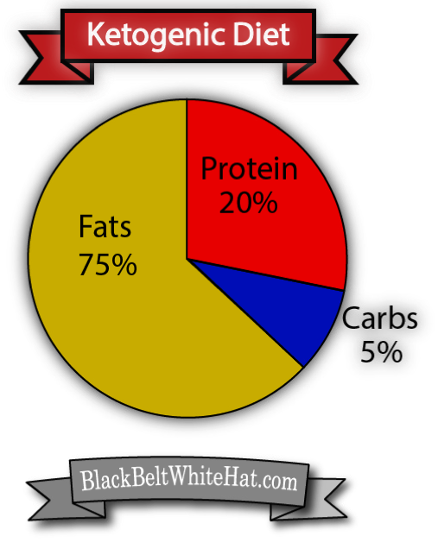

The History of the Ketogenic Diet

The ketogenic diet has been around for quite some time and it’s not another fad diet. Fasting has been used to treat health conditions since 500 BC (according to available records) and the ketogenic diet was established in the 1920s by physicians as a way to replicate the metabolism of fasting, in order to treat epilepsy in children.
What is Ketosis?

Ketosis your body start utilising ‘ketone bodies’ which are produced by the liver breaking down fatty acids in periods of either fasting, or low carbohydrate intake.

Your body will always use glucose, from carbohydrate-intake as an energy source for the brain and muscles working a higher intensity, when it is available in large enough quantities.

When blood glucose remains low, and can’t be ‘topped’ up from stores in the body (called glycogen), fatty acids are broken down to form acetyl-CoA, which in turn is used in the synthesis of ketone bodies.

Acetyl-CoA is normally used to produce energy from glucose, but can’t in the absence of glucose and oxaloacetate.

It is theorised that your brain could function ‘better’ in ketosis because of the fact that it can yield more energy per gram of ketones, then per gram of glucose.

What are the Ketones / Ketone Bodies?

Acetoacetate, beta-hydroxybutyrate, and acetone.

Acetone is formed via the ‘ decarboxylation’ of acetoacetate

What are the Benefits of the Ketogenic Diet?

Reduced appetite due to steady (low) blood sugar levels
Lower insulin levels & glucose levels in the blood mean massive reduction in risk of Type 2 diabetes
Increased mental performance
Research states that the ketogenic diet is easier to stick to than a low fat diet
Mounting evidence that the ketogenic diet can fight & prevent most forms of cancer
Mounting evidence & anecdotes that the ketogenic diet is good for mental health

Enhanced wound healing (research available is mainly on rats)

What are the Side Effects of the Ketogenic Diet?

Maximum power output decreases.
Fatigue & brain fog in the first 2 weeks
Bad breath in the first 2 weeks
Low blood sugar – requires monitoring in the first few weeks due to risk of fainting

The main issue for me is the reduced power output, and reduced exercise capacity at higher intensities.
This can be offset somewhat, in theory, by supplementing creatine, but this doesn’t seem to be that effective.

Consume 10g of pink salt with 2/3 litres of water per day on ketosis, especially in the first 2 weeks

What is Targeted Ketosis?

Targeted Ketosis may be the best way of offsetting the decrease in strength & power from a ketogenic diet.
Consume 50g of carbohydrate 30 minutes before exercise, try doing this twice a week to begin with. Other ‘training days’, you can in theory have your 50g of carbs before, but the more often you do this, the longer you’ll be kicked out of ketosis.

Consume high GI carbs before your training, such as maltodextrin.

Tips For Starting a Ketogenic Diet

Start Off Reducing Carbs Slightly

It’s difficult to jump straight into ketosis, if you’ve researched and planned extensively, then you might be able to ignore this, however; most of us are not that organised.

Try keeping your normal 3 meals a day, but snacking exclusively on low-carb foods. Once you’ve found some snacks you like, then look to replace one meal at a time with a ketogenic-friendly, low carb meal.

Check your Macros

Macronutrients – i.e. carbohydrates, fats and proteins (fibre is, strictly speaking a carb that doesn’t, normally, get broken down).
Lots of us are used to estimating or counting calories from normal, high carb foods, but doing the same with fats is very difficult, unless you are used to it. So weigh your foods and get exact calories when you are starting off.

Water Intake

People often run into problems on the ketogenic diet because they don’t drink enough water. Eating a ketogenic diet can make you less thirsty, or in my case, I tend to want hot drinks, rather than water. You may also be eating less food with a high water content such as fruit and therefore need to compensate with a greater water intake.

Electrolyte Intake

Ensure that you are getting enough sodium, potassium and magnesium. Using pink salt on your food and drinking coconut water are the easiest ways of ensuring you are not depleted.

Keto Sweetners

Stevia is the go-to sweetener for many people on a ketogenic diet.

Eat Plenty of Vegetables

Don’t just stick to high fat foods, eat plenty of vegetables for the micronutrients and fibre.

Ketogenic Shopping List

Organic Grass Fed Meat

Ground Beef
Chicken breast
Chicken drumsticks
Steak
Bacon (not cured in sugar)
Pork chops
Wild Fish

Sardines
Salmon
Tuna
Nuts

Almonds
Pecans

Dairy

Full fat milk
Cheese
Full fat yoghurt
Vegetables

Brocolli
Spinach
Salad
Green beans
Cauliflower
Asparagus
Mushrooms
Kale

Fruit

Avocado
Oils

Coconut oil
Olive Oil
Lard (not an oil but great for frying)
Other

Hummus
Bone broth
Butter
eggs
Peanut butter (check nothing added)
Almond butter (check nothing added)
Supplements

MCT Oil
Psyllium husk
Stevia
Cacao powder

Note – with MCT Oil and coconut oil, start of with low amounts or you might poo your pants.

Ketogenic Snacks

Pumpkin seeds

Almonds

Dark chocolate

Hummus and vegetable sticks

Sardines

Eggs

Fat bombs

Cheese

Ketogenic Diet Plan

Breakfast

Low carb smoothie

Blend ingredients shown below

Avocado
Almond milk (low carb version or home made)
Handful of spinach
1 tbsp of coconut oil
Sweetener – stevia
Hemp protein powder – 30g
Chia seeds
Cacao powder – 1/2 tbsp

Or – bulletproof coffee – Coconut oil (& optional cream) in coffee.
Be careful not to burn your mouth on the oil.

Lunch
Egg & Feta Salad with avocado

Or

Tuna salad with mayonnaise

Dinner

Chilli Chicken Thighs

One crockery pot or tray
Chicken thighs
Olive oil
Chilli powder
Pink salt
Pepper
Preheat oven and cook for approximately 20 minutes

For additional calories –
Athletes that require additional calories – coconut milk, but not the watered down stuff in cartons, is an easy source of calories. Look for tins which are around 50% coconut milk, as the 100% coconut milk has to be spooned out of the tin. The 50% stuff can be added to a blender easily, just thrown in some cacao powder, or neck it from the tin.

Fibre – Ensure you eat enough fibre on the keto diet, or you can get pretty backed up!

The Alkaline Diet

The Alkaline Diet has many claims associated with it such as increased bone density, enhanced immunity and even a reduced risk of cancer.

As vegetables tend to be alkaline and meat tends to be acidic, ‘veganism’ is often incorporated into the diet – i.e. Vegans are also often on the alkaline diet (Vegan Diet explained on a previous blog post).

vegan diet for athletes

The basic principle is that, in theory at least, replacing acid-forming foods, such as meat and dairy, with alkaline foods such as raw, green & leafy vegetables, can improve health.

Some proponents even claim that an alkaline based diet can help fight cancer. This sounds quite outlandish, but I have found 1 study which shows that bicarbonate of soda (AKA Baking Soda), a very alkaline ‘food’ can reduce tumour size, albeit in large quantities. Whether or not the health benefits of the alkaline diet are down to the alkaline levels of the food per se, or the nutrient-dense foods that comprise the diet, is difficult to establish.

The diet is also known as the ‘alkaline-ash diet’ because it is believed that once a food has been broken down and utilised for energy by the body, it leaves behind an ash residue. If a food produces an acidic ash, then it is thought to make you vulnerable to a number of diseases.
It’s important to note that food cannot change the pH of your blood – which should always remain between 7.35 and 7.45, but I can have an impact on the pH of urine. Those athletes who have ever supplemented with baking soda or beta alanine, will also tell you that the pH of your muscles can also have a dramatic impact on the way you feel and perform during intense exercise such as grappling or MMA.

Modern scientific research does not support the theory that the alkaline diet prevents cancer, but many point out the many flaws in modern research, with much of it being sponsored by pharmaceutical companies (there’s even a union of concerned scientists who refuse corporate funding because of how corrupting it is). If you look hard enough, there’s the odd study knocking about, like the baking soda one mentioned above. There are also studies which suggest that our ancestors ate diets which were high in alkaline foods – about 87% of all the foods consumed before agriculture & farming became a thing, were thought to have been alkaline.

Foods to Avoid on the Alkaline Diet

Meat, poultry, fish, dairy, grains and alcohol

Foods to Eat on the Alkaline Diet

Fruits, nuts, legumes & vegetables
Grains

Buckwheat
Millet
Quinoa
Lentils
Soy Beans
Red Beans
Sprouted Bread

Grasses

Wheatgrass
Barley grass

Oils

Olive Oil
Flax Oil
Coconut Oil
Nuts & Seeds
Almonds
Coconut
Pumpkin Seeds
Sunflower Seeds
Pecans

Alkaline Diet – Diet Plan

Breakfast

Hemp seed, kale & almond milk smoothie

Lunch

Avocado, lettuce and pistachio salad

Dinner

Chickpea curry

Distilled water throughout the day

Snacks

Nuts, seeds – a bit of a cheat meal for lazy people like me would be hemp seeds, olive oil and kale-powder shake. Eat plenty of raw green leafy vegetables.

Cashews & almonds are considered to be the only nuts that are alkaline forming

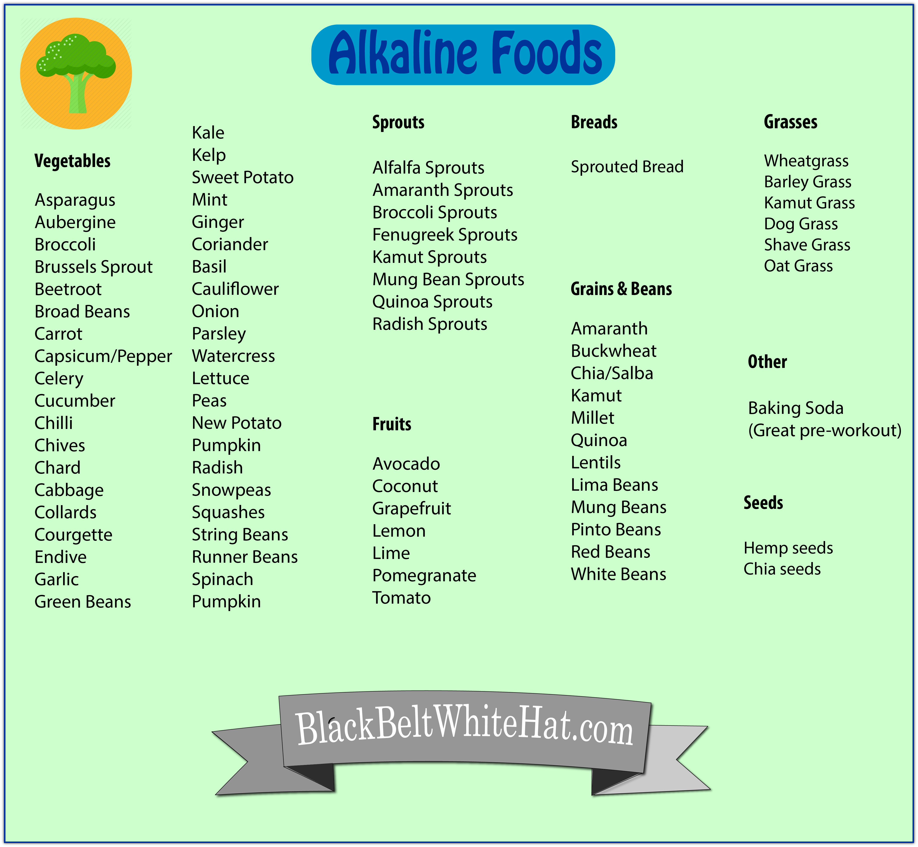

The vegan diet is becoming more and more popular…it was rare to hear about someone who was on a vegan diet until the China Study came out in 2005 and then it really gained momentum when a leading medical doctor published the book “How Not to Die“. The book basically recommends a varied plant and wholegrain diet to treat all common diseases

Benefits of a Vegan Diet

Compared to the average western diet, a typical Vegan Diet has the following benefits:

– Higher in fibre

– Reduced risk of heart disease

– Higher in vitamins, especially vitamins A, C and E

– Higher in minerals such as magnesium

– Reduced risk of developing certain cancers (pretty much all of them)

– Phytochemicals in organic fruits and vegetables are linked to decreased in oxidative stress- important for athletes looking to avoid burn out and overtraining

– Vegan diets also tend to be cheaper. Compare the price of an organic chickpea curry, to the price of an organic chicken curry, for example

Negatives of Vegan Diet

– Constantly explaining to people why you don’t eat meat – nightmare with the grandparents and mother-in-law at Christmas

– EPA, a constituent of omega 3 is hard to obtain on a strict vegan diet

- Vitamin B12 can be hard to obtain in optimum amounts unless supplemented

To summarise…a whole food organic vegan diet significantly reduced the risk of all of the most common causes if mortality and illness, when compared to a typical western diet, it can be tricky to get enough EPA, b12 and iron and a right bastard to explain to old people and bodybuilders.

Some may argue that the health benefits come mainly from the lack of junk food, sugar and factory farmed meat, rather than the elimination of all animal products itself. Either way, there is undoubtedly a link between vegan diets and reduced risk of a great number of diseases.

One of the main issues with the meat & animal products consumed in a normal Western Diet, is the amount of anti-biotics and hormones used to produce massive quantities of meat, unnatural amounts of milk etc at minimal expense.

Vegan Diet & Athletic Performance

More & more athletes are moving over to a vegan diet. One of the pioneers of this shift away from protein drinks and Lucozade was ultra-marathon runner Scott Jurek.

The argument against vegan diets used to be that the quality of protein required, was difficult to obtain but thanks to the number of hemp products now on the market, this is no longer the case. Athletes have traditionally focused on the periods before, during and after training and competition, and ignored the need for a base of good health with a diet rich in nutritious whole foods. The vegan diet has begun to reverse this trend, consuming a nutritions foods everyday, which reduce inflammation and aid recovery & adaptation.

Vegan Diet Plan for Athletes

Breakfast

Porridge with homemade almond milk, ground almonds, banana & Quinoa

Snack

Banana Granola Bars or pumkin seeds with goji berries or hemp protein shake with organic olive oil

Lunch

JUMbowl Salad

Snack

Vegan energy balls

Dinner

Healthy Vegan Chilli

The Paleo Diet

The Paleo diet is often called The Caveman Diet. Cavemen didn’t have agriculture or processed foods, they were ‘hunter gatherers’.

Foods to Eat on the Paleo Diet

You eat lots of meats, plants, vegetables, fruits and drink lots of water.

Lots of non-cave-many stuff are also on the diet however, red wine, espresso,

Grass fed meat
Wild fish
Fresh fruit
Fresh vegetables
Eggs
Nuts
Seeds
Unrefined oils such as coconut oil and olive oil
Spices
Unrefined fats such as grassfed butter (some argue that this shouldn’t be included in a Paleo diet however as it’s dairy)
Sweet potatoes

Foods to Avoid on the Paleo Diet

Dairy is restricted or eliminated, as are grains.

Foods you can’t eat –

Dairy (mostly)
Cereal Grains
Sugar (refined)
Processed foods
Vegetable oils
Sweetners
Trans fats
Legumes
Low quality meat
Starchy vegetables such as ‘normal’ white potatoes
Alcohol is limited

Benefits of the Paleo Diet

It’s healthy – With no processed foods or sugar, the diet has anti-inflammatory benefits
Reduced likelihood of developing type 2 diabetes compared to conventional Western diet
Improved gut health – thanks mainly to high quality foods that are ingested on the diet
Full of vitamins & minerals
No food additives (or greatly reduced amount)
Improved satiety — a feeling of fullness between meals meaning you’re less likely to snack
Cons of the Paleo Diet

The price. Unfortunately wild fish & grass fed beef are a lot more expensive than factory farmed options.
No dairy & no grains – can be good or bad depending on the person
Very difficult to get enough protein if you’re a vegetarian on this diet. Although hemp is a great source of all amino acids and Paleo friendly.
Can be tricky for athletes to get enough carbohydrate for optimal performance. Some argue that this depends on the sport and that most people adapt to a lower carb diet within 4-8 weeks
Overall the Paleo diet is a lot healthier than the average Western diet, full of organic whole foods.

Paleo Diet Shopping List

Vegetables

Spinach
Brussels Sprouts
Broccoli
Kale
Carrots
Peppers
Beetroot
Asparagus
Cucumber
Celery
Butternut squash
Cabbage
Sweet potatoes

Fruit

Oranges
Apples
Pears
Tomatoes
Berries
GrapesMango
Pears
Pineapples
Avocados

Meat & Fish

Organic grass-fed beef
Organic chicken thighs & breast
Wild Salmon
Nitrate free bacon
Tuna

Other

Organic Free Range Eggs
Almond butter (peanut butter is not allowed as it’s a legume )

Oils

Coconut oil
Olive oil
Organic ghee

Nuts and Seeds

Almonds
Pecans
CashewsHazelnuts
Pumpkin seeds
Sunflower seeds
Walnuts

Organic Spices

Cinnamon
Basil
Garlic Powder
Turmeric

Drinks

Coffee
Coconut water
Kombucha

Paleo Diet Plan

Breakfast – Omelette with spinach

Snack – Pumpkin seeds with goji berries

Lunch – Salad with kale, spinach, avocado & chicken or bacon or tuna

Snack – Beef jerky

Dinner – Salmon, fried with vegetables

Snack – Primal Bar or home made protein bar or pecans

If you need extra calories, coconut milk is awesome. Use tins or powdered coconut milk, not the cartons which are about 2% coconut milk, 97% water and 1% E numbers

Intermittent Fasting

It would be easy to dismiss intermittent fasting as the next fitness fad, but it is backed up by a substantial amount of research. Intermittent fasting is based upon the theory that our bodies evolved in the Paleolithic era (50,000 to 10,000 BC) to adapt specifically to a lifestyle and environment characterised by periods of famine and feast. The theory behind intermittent fasting dictates that these alternate periods of restricted caloric intake are required for optimal metabolic function.

Benefits of Intermittent Fasting
The list of proposed benefits relating to intermittent fasting are indeed extremely impressive. They include improved blood lipid profiles, increased growth hormone secretion, accelerated autophagy (the process of cells recycling waste matter), increased insulin sensitivity and studies on animals have also suggested it may have some beneficial effects relating to the prevention of cancer and cognitive function. One of the main mechanisms behind intermittent fasting and all these health benefits, appears to be a reduced secretion of a hormone called IGF-1. This is a hormone that accelerates the aging process and has been linked to a number of diseases, especially when present in the body in relatively high amounts.

Intermittent Fasting Protocols

Alternate Day Fasting
This protocol involves one day of consuming 1/5th of normally energy needs (between 400 and 700 calories depending on bodyweight), and on the next day consuming what you would normally eat – i.e. your usual daily diet. This alternate day fasting is normally continued for a period of up to 8 weeks, although some nutritionists, somewhat controversially, advocate doing it continuously.

The 5:2 Fast
Following this system, as you may have guessed by it’s title, involves spending 2 days a week on a diet that is extremely low in calories. Again 400 to 700 calories depending on body weight, is normally recommended on fasting days.
The fasting days should NOT be consecutive. Again this style of fasting is normally adhered to for up to 8 weeks at a time.

The 16:8 Diet
This is where you normally stop eating at 8pm in the evening, and then don’t eat until 12pm the next day. You need to plan diligently for this protocol, ensuring you eat good quality food in your 8 hour window, and not rubbish to meet your calorie-needs.

Training and Intermittent Fasting
Studies have suggested that exercising whilst in a fasted state, although should be done under supervision and with care, can actually lead to improved athletic performance.

Keeping workouts short (less than 30 mins) and intense, can help enhance the use of fat as a substrate/fuel, whilst enhancing Growth Hormone secretion. Growth Hormone in turn, leads to an enhanced anabolic response – i.e. greater potential to build muscle.

Training in a fasted state can also enhance adaptation to endurance exercise. Studies have shown that training with extremely low levels of muscle glycogen/carbohydrate causes an increased “oxidative capacity” by enhancing the formation of new mitochondria (an element of muscle cells vital to endurance).

For bodybuilding purposes, an example fasting workout programme may look like this:

Day 1:
Deadlifts – 2 sets of 3 – 6 reps
Barbell Bent Over Row – 2 set sets of 8 – 12 reps
Lat Pull down (or chin ups) – 1 sets of 6 – 10 reps
Hanging Leg Raises – 1 set of max reps

Day 3:
Barbell Bench Press – 2 sets of 6 – 10 reps
Dips – 2 sets of 6 – 10 reps
Explosive press ups – 1 sets of max reps
Ab roller – 1 set of max reps

Day 5:
Squats – 2 sets of 6 – 10 reps
Military Press – 2 sets of 6 – 10 reps
Bulgarian Split Squat – 1 sets of 10 – 15 reps on each leg
Stability Ball Pikes – 1 set of max reps

Remember to warm up and cool down before and after each session

Supplements and Intermittent Fasting

BCAAs
Many fitness professionals advise people to take 10g of BCAA approximately 20 minutes before and 10g immediately after training in a fasted state. The theory behind this is that, whilst the body is still starved of carbohydrate, it will experience the same increased secretion of Growth Hormone, and the BCAA supplementation will capitalise on this, further increasing protein synthesis. Interestingly, fitness professionals appear to disagree on whether or not the calories in BCAA should be counted towards your daily total. 10g of BCAA contains around 40 calories.

Whey Protein
Whey protein isolate or concentrate can be taken after a workout but the additional calories need to be accounted for when fasting. 1 scoop of whey protein powder will contain around 100 calories – check the label to find out exactly.

Fish Oil
Other supplements may be required to make meals during fasting days, “nutrient dense” – you should make those 500 or so calories as nutritious as possible. Supplements that could help you achieve this, include fish oil liquid or capsules, and ‘green powders’ such as wheatgrass and spirulina can also be consumed and are recommended by many nutritionists.

Carbohydrate Cycling

Carb cycling involves days of eating a range of high carbohydrate foods, days of moderate carbohydrate intake and often days of low or no carbohydrate intake.
Carbohydrate / carb cycling is said to stimulate certain metabolic functions, such as insulin sensitivity, thyroid hormones and leptin* – which in turn has benefits for health, fat loss and potentially muscle hypertrophy (muscle-size).
In it’s simplest form, a carb cycling diet would involve eating a high amount of carbohydrate on training/exercise days and lower carbohydrates on rest days.
The basic concept is that having low carb days will make you more ‘insulin sensitive’ meaning that when you do eat a high amount of carbohydrate, more of it will be shuttled to the muscles for fuel and less will be stored as fat.

In theory this has the opposite effect of type 2 diabetes; whereby constant high sugar consumption, effectively stops insulin from working as well, and blood sugar rises, more carbs are stored as fat and very little is stored in the muscles (especially if you don’t exercise).

Whilst on a carb cycling diet, a middleweight MMA fighter might consume 350-400g of carbohydrates on training days and 75-100g on rest days. On training days, the same fighter may aim to consume 3500 calories in total and 3200 calories on rest days.
For greater insulin sensitivity, he may also do a very low carb & high fat day, whereby he eats 30g of carbohydrate only.
Lower carb days might involve eating more vegetables, grass-fed organic meat, wild fish and healthy fats such as coconut oil. Typically protein intake remains fairly consistent throughout a typical week, however fat intake will increase on rest days/low carb days.
In theory, you could be ‘carb cycling’ and eat rubbish, low quality carbs on high carb days and still be adhering to the protocol, however, in order to gain the greatest health benefits from this diet, people will normally eat carbs on high carb days from sources such as:

High Quality Carbohydrate Foods
- Sweet potatoes
- Oats
- Brown rice
- Quinoa
- Yams
- Wholegrains

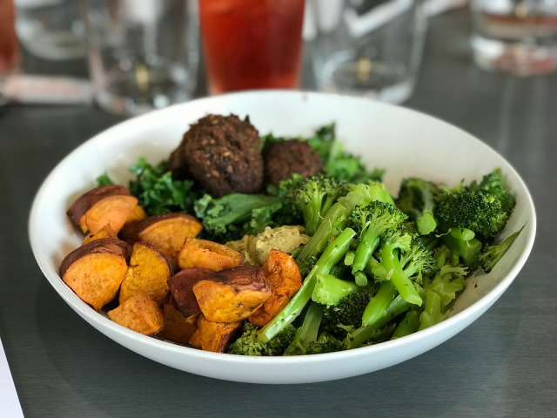
Sweet Potatoes are one of the most nutritious sources of carbs

Benefits of Carb Cycling

- Higher insulin sensitivity / reduced risk of developing type 2 diabetes (as long as high carb days don’t contain high amounts of sugar)
- Possible to enter ketosis if carbs are manipulated appropriately, which can have numerous health benefits
- Some anecdotal evidence that it can help increase strength thanks to ‘carbohydrate super-compensation‘
- Some evidence that it can increase lean muscle mass
- Scientific evidence that it promotes fat loss to a greater extent than traditional method of calorie restriction alone. Study here.

Carb Cycling Diet Plan

High Carb Day

Breakfast
High Protein Porridge
Ground Almonds
Oats
Banana
Raisons
Raw Honey
Cinnamon to taste
Lunch
Egg salad with pasta and plenty of raw green vegetables
or
Chicken salad sandwiches using wholemeal bread
Dinner
Stir fry with brown rice
Snacks
Banana
Rice cakes
Oat Cakes

Low Carb Day
Breakfast
Low carb smoothie
Whey or hemp protein powder
20g coconut oil or cream
2 ice cubes
1 tbsp peanut butter
Handful of spinach
Snack
Whey Protein shake with flax seed powder
Lunch
Feta cheese salad with olive oil & lots of raw spinach & kale
Handful of nuts
Coffee with coconut oil
Snack
Hummus and carrot sticks
Dinner
Low carb Cajun Cauli Hash
Add smoothie if extra calories are required
– Tin of coconut oil (check at least 50% coconut oil, cartons are typically 2-3% and tins which are 100% are more difficult to blend as they are solid at room temp)
– Raspberries
– Hemp seeds
– 10ml olive oil
– 10g peanut butter

*Leptin is a hormone which signals when you are full
Quotes About Diet from Experts & Amateurs

Ian Crump
Strength & Conditioning Coach
“I look to consume healthy, organic whole foods and get adequate protein from grass-fed meat and wild fish. Sweet potatoes are my go-to source of carbohydrate. I don’t really stick to a specific dietary protocol or regime, although I am interested in the health benefits associated with diets high in alkaline foods and the ketogenic diet”.



Expert’s Twitter Account

Scott Jurek
Ultra Marathon Runner
“To test my limits I ventured into the world of ultra-endurance triathlon, and within 3 years accomplished athletic feats I could have never previously dreamed possible, including top finishes at the Ultraman World Championships and becoming the first person to complete EPIC5: five ironman-distance triathlons on five Hawaiian Islands in under a week.
Anecdotally, and without reservation, I submit that these accomplishments were achieved not in spite of, but as a direct result of putting animal products in the rear view. No beef, no chicken, no pork, no fish, no milk, no cheese, no eggs. Just plants.”
Source
Athlete’s Website

Andy Flint
Strength & Conditioning Coach

“I mainly look to eat well and hit my macros each day. I travel a lot with my job & company so it’s difficult to plan day to day but always opt for organic whole foods where possible. I have used the ketogenic diet for short periods of time as an effective way to lost body fat”

Expert’s website

Sheldon Howard
Martial Arts Champion

“I literally went from crippling pain to good health in a matter of weeks. When I made the decision, I was very worried I’d lose all my hard-gained muscle. Wrong! I’m currently the same lean body mass and weight I was in 2003 before I switched to a plant-based diet.
This life transformation happened over eight years ago and I’ve been going strong ever since.”
Source

Final thoughts...

With all the different dietary protocols around at the moment, it is difficult to know which way to turn for better athletic performance.
The best thing to do is read about each diet, pick out elements which you think make sense and try things for yourself.

For further reading

Use Google Scholar to look up studies related to each diet & supplement

For the ketogenic diet see some of the work by Dr Dominic D’Agostino

Remember to use organic, whole foods when possible and you won’t go far wrong

This book was written by me! Drew Griffiths. I have 1st Class Degree in Sport Science from Loughborough University; an MSc in Exercise & Nutrition from the University of Liverpool (studied in Chester, awarded by Liverpool) and quite randomly, a Chartered Institute of Marketing (CIM/CAM) Diploma in Digital Marketing from the Oxford College of Marketing.
I used to be personal trainer, I’ve had 8 amateur MMA fights and 1 full contact kickboxing fight.
I write for the GoodMenProject, Business2Community , CureJoy.com, CareerFuel.net and have contributed to several martial arts publications
Follow me on Twitter – @MMATRAINING1980

Please visit my website – www.BlackBeltWhiteHat.com

